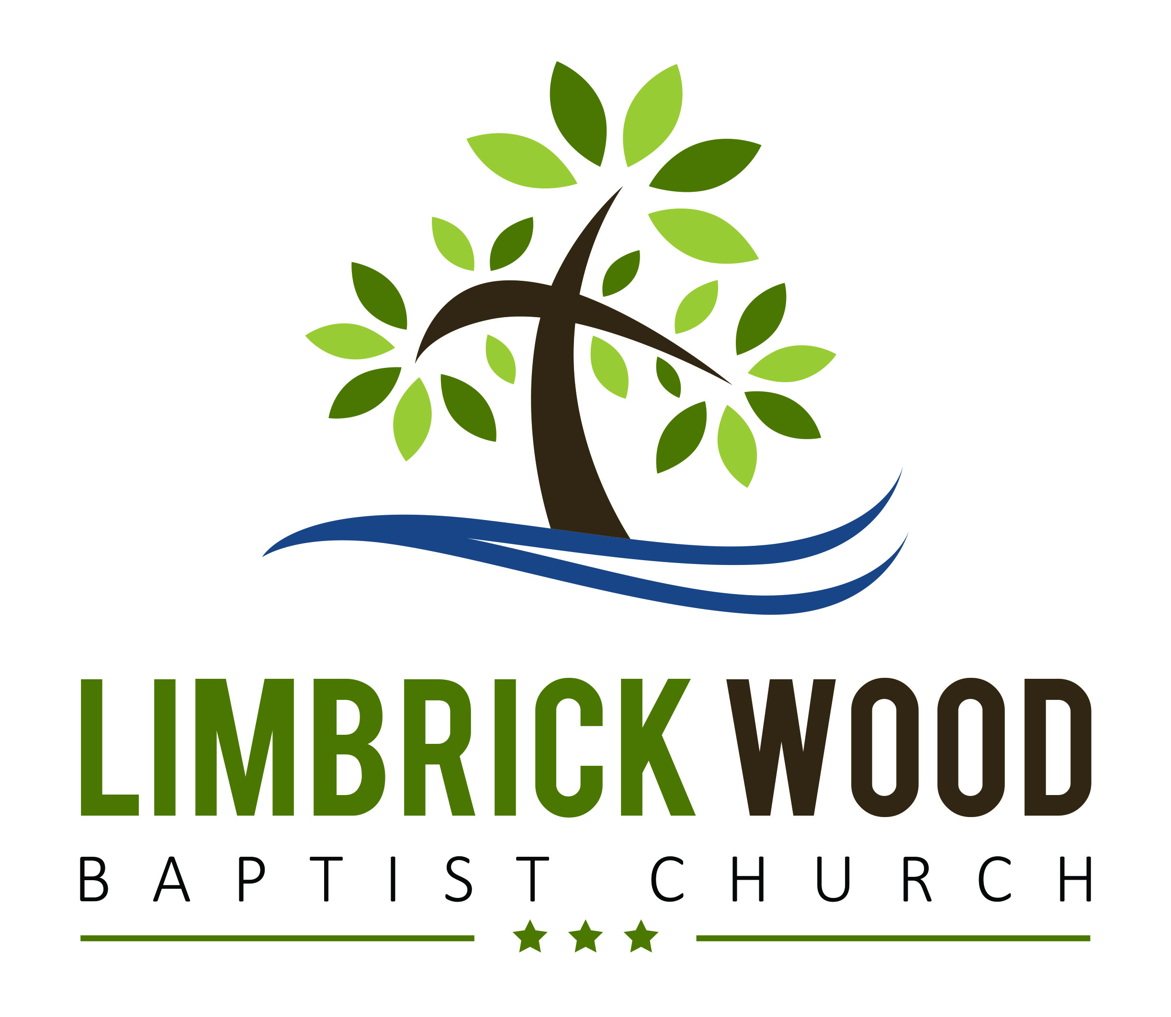
TO SET UP REGULAR GIVING
OR MAKE A DONATION

If you would like to give to the ministry and work at LWBC, this form shows various ways you can do this. Completing it helps us to plan financially, claim gift aid where possible and offer our thanks for your generosity.

Name __________________________________
Address ________________________________
_______________________________________
Postcode _______________________________
Telephone ______________________________
Email __________________________________

All information supplied is kept in strict confidence and not shared with any third parties

Individual Gift: Please circle as appropriate:
Amount: £_________ CASH / *CHEQUE / **BANK TRANSFER

* Cheques should be made payable to: ‘Limbrick Wood Baptist Church’
** Bank Transfers should be made to: Limbrick Wood Baptist Church - Barclays - Sort Code: 20-45-45 - Account: 50048925

Signed: ____________________________ Date: ____________________

Regular Giving Pledge: Please tick the appropriate box:

This is a new pledge This pledge is in addition to my previous pledge(s) This replaces my previous pledge
Amount: £ ________ weekly / monthly / quarterly starting the____ (day) of ___________ (month) ______ (year)
Bank details to set up a standing order: Limbrick Wood Baptist Church - Barclays - Sort Code: 20-45-45 - Account: 50048925

Signed: ____________________________ Date: ____________________

A pledge is a confidential written promise to give money in the future – it may be a one-off lump sum or installments over a period of time.
It isn’t a legally binding contract, and a pledge can be reviewed and changed at any time, and as circumstances change.
Pledges enable the church to plan its long-term finances more effectively and to determine the level of financial commitment we are able to undertake.

Other ways of giving

Please tick any appropriate boxes and provide any details you can. We will contact you to discuss these further.

Leaving a legacy to LWBC in your will ________________________________________________________________

Gifts in kind (e.g. building materials, specialist skills, etc) ________________________________________________

LWBC uses regular giving envelopes, would you like to know more?

Please note that there is a weekly offering taken at LWBC at our main services for which we thank God.

‘Gift Aid’ it: Tax efficient giving - make your gifts go 25% further!
We can claim 25p for every £1 you give or have given over the last 4 years. You must be a UK taxpayer, paying an amount of income tax or capital gains tax equal to the tax we claim on your donation in the tax year. If your circumstances change and you no longer pay enough Income Tax or Capital Gains Tax to cover the amount claimed by the church, you can cancel this declaration at any time by notifying the church. If you are a higher rate tax payer you can claim personal tax relief via your Self Assessment Tax return. If you are married and both pay tax, two separate declarations will need to be made if you wish us to collect tax from both of you. Please notify the church if you change your name or address. See Inland Revenue’s ‘Giving to charity through Gift Aid’ guidelines at http://www.hmrc.gov.uk/individuals/giving/gift-aid.htm

I am a UK taxpayer and agree to the terms above - Please reclaim the tax on all my gifts indicated on this form and any
donations I make in the future or have made in the past 4 years to Limbrick Wood Baptist Church (please tick if appropriate)
Signed: ____________________________ Date: ____________________
Limbrick Wood Baptist Church, Corner of Jardine Crescent and Faseman Avenue,
Tile Hill North, Coventry. West Midlands. CV4 9RD : www.LWBC.org.uk : pastor@lwbc.org.uk

